

ELECTRIC FRIES STATION

Instruction manual

MOEDL: INF-CW8

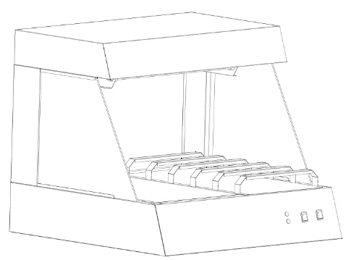

ALL STAINLESS STEEL CONSTRUCTION
AUTOMATIC THERMOSTAT
HIGH-EFFICIENT,EASY OPERABLE&SAFE
DURABLE AND ELEGANT DESIGN

Table of Contents

Section Page

Introduction ................................................................................3

Technical Specification ...............................................................3

Operating Instruction ....................................................................3

Operation Step ..............................................................................3

Maintenance ..................................................................................3

Note................................................................................................5

Circuit Diagram................................................................................6



Introduction :
INF-CW8 Table Top Electric Fries Station is designed combine with virtues of abroad and home. This series adopted the international popular style design, good quality of stainless steel body, luxurious and good-looking.The products are equipped with electrical elements from famous factories so that they are energy-saving and safe. It is the best choice for Supermarket as well as refreshments shop.
Technical Specification :
Model | Voltage/frequency | Power | Dimension | N.W.
INF-CW8 | ~240V,50Hz | 1.5 kW | 600*610*700mm | 21kg

Operating Instruction :
The appliance heat and keep warm the food with infrared ray bulb and heating element to radiate with infrared ray.
Operating Steps :
- Set the bulb(Screw it tightly), connect the power,then put on the switch to power on.
- Please don’ t touch the bulb and the heating element during working and just stop working.In case of scalding.
- To clean the oil in the oil basin after using, just open the door of the cupboard or take the chips pan away, put out the oil basin to clean.
- It is prohibit to use corrosive sustance or cleaner to clean the appliance.

Maintenance
After use, you should use a wet cloth to clean. DO NOT IMMERSE IN WATER.

Note :
- Read all instruction before installation and using
- This appliance is not intended for use by persons (including children) with reduced physical, sensory or mental capabilities, or lack of experience and knowledge, unless they have been given supervision or instruction concerning use of the appliance by a person responsible for their safety.
- Children should be supervised to ensure that they do not play with the appliance.
- If the supply cord is damaged, it must be replaced by the manufacturer, its service agent or similarly qualified persons in order to avoid a hazard.
- Do not use or store the appliance outdoor and where it will be exposed to the weather or to temperature below freezing.
- Always switch off the appliance and set the disconnection device in the fixed wiring in OFF position after each use of appliance and before cleaning and maintenance.
- Other than cleaning mentioned in this instruction manual, no additional maintenance or servicing is needed
- Where this appliance is to be positioned in close proximity to a wall, partitions, kitchen furniture, decorative finishes, etc., it is recommended that they be made of noncombustible material; if not, they shall be clad with a suitable non-combustible heatinsulating material, and that the closest attention be paid to fire prevention regulations.
- DO NOT DISMANTLE OR REPAIRE THE APPLIANCE BY YOURSELF - Repairs, when necessary, must be performed by authorized professional or the agent
- DO NOT TOUCH HOT SURFACE — The temperature maybe higher when the appliance is operating
- DO NOT PLACE THE APPLIANCE ON UNSTABLE SUPPORT OR INCLINED PLANE.
- ALWAYS CHECK THE POSITION OF THE CONTROL SWITCH WHEN YOU HAVE FINISHED COOKING TO MAKE SURE ALL SWITCH ARE IN OFF POSITION
- DO NOT HEAT UNOPENED FOOD CONTAINERS — Build-up pressure may cause container to burst and render injury
- DO NOT STORE FLAMMABLE MATERIALS IN THE OVEN OR NEAR THE OVEN
- DO NOT USE THE APPLIANCE IN A DUSTY ENVIRONMENT OR IN AN EXPLOSIVE ATMOSPHERE (INFLAMMABLE GASES, VAPOURS, VAPOURS FROM ORGANIC SOLVENTS).
Circuit Diagram :
~220V~240V/50Hz
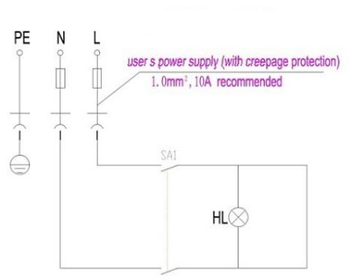
SA: ON / OFF Switch HL: Heating Indication Light

