INF- Series
French Fries Display Warmer
Operation manual

This product is designed for fried potato clips sold in supermarkets, hotels and restaurants. It has the characters of good-looking and easy operation.
- Specifications:
Model | INF-CD
Name | Chip dump
voltage(V) | 220
power (kW) | 1300W+300W×2
frequency(Hz) | 50/60
unit size (mm) | 640×710×1530
2. Transportation and storage
Because it is easy-broken product, in transportation, it should be very careful, prevention from heavy vibration and it should be very careful during move. The equipment in package cannot be put in open-air for long time. It should be put in the good facility of air and non-corrosive air storage.
3. Notices and operation environment:
a. Because the main electric equipment is lights. In cleaning, never water it directly to prevent from humidity and damage of the electric capacity.
b. After operation for long time, there will be some oiled dust on the surface of the light, you should clean it on time. For safety, before cleaning, you should cut off the power first and wait until the light is cool, then take it out. It is forbidden to clean it when the light is still hot to prevent the light from breaking due to expanding with heat and contraction with cold.
c. The working site should have enough space around for good air ventilation.
d. This equipment is not equipped to be used by unwell, unresponsive or mentally disturbed people, including children, unless under the guidance or help of persons who are responsible for their security. Keep an eye on children and keep them away from playing around the equipment.
e. Measures should be taken to prevent the equipment from falling off in case it is put on a stander.

4. Electric diagram:
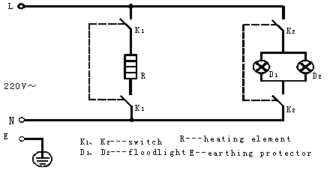
5. Troubles and solutions:
Troubles | Causes | Solutions
The lights is off partly | the lights are damaged or the wire | replace bulbs and check
The light is off totally | Connection is bad. troubles with switch | Wire terminals replace switch
6. Cleaning and maintenance:
- The product is made by stainless steel. You can clean it with non-corrosive detergent.
- For the oiled dust, you cannot use metal ball to clean it, which can damage the surface of product.
Warning: Don’t clean the machine by using steam cleaner.
Appendix parts list: an operation manual

